***TASK 12: JAVA COLLECTION AND PACKAGE***

***1.Q🡪Create package name🡪 “com.example.hr”***

***Include🡪class name🡪Employee***

***Fields🡪name, id, salary.***

1. ***Employee class🡪should have🡪method***
2. ***Create 🡪public void printName()***
3. ***Create 🡪public void printsalary()***
4. ***Create 🡪second package name🡪”com.example.hrtest” , create class name🡪EmployeeTest🡪include🡪main method() ,create an instance of Employee class(from 🡪”com.example.hr”) that are name, id, salary and and calls method.***
5. ***Use import 🡪import the “com.example.hr”(package)🡪access the Employee class.***
6. ***Compile and run classes.***

***Answer:***

**Package🡪”com.example.hr”**

**Class🡪Employee**

***Code:***

**package** com.example.hr; //create package name--> com.example.hr

**public** **class** Employee { //create class name-->Employee

//instance variable

**private** String name;

**private** **int** id;

**private** **double** salary;

**public** Employee(String name, **int** id, **double** salary) { // create a constructor

**this**.name=name;

**this**.id=id;

**this**.salary=salary;

}

**public** **void** printName() { //create method name-->printName

System.***out***.println("Name::"+name);

}

**public** **void** printSalary() { //create method name-->printSalary

System.***out***.println("salary::"+salary);

}

**public** **void** printid() { //create method name-->printid

System.***out***.println("id::"+id);

}

}

***Package 2🡪”com.example.hrtest”***

***Class name🡪EmployeeTest***

**Code:**

**package com.example.hrtest; //create package name-->com.examle.hrtest**

**import com.example.hr.Employee; //import -->Employee class package-->com.example.hr-->com.example.hr.Employee**

**public class EmployeeTest { // create class name-->EmployeeTest**

**public static void main(String args[]) { // create main method**

**Employee employee_object=new Employee("paramu",23, 30000); //create Employee class object and passing parameter**

**employee_object.printName(); //accessing the methods in Employee class using object**

**employee_object.printSalary();**

**employee_object.printid();**

**}**

**}**

**________________________________________________________________________**

***Code and output screeenshot*** :

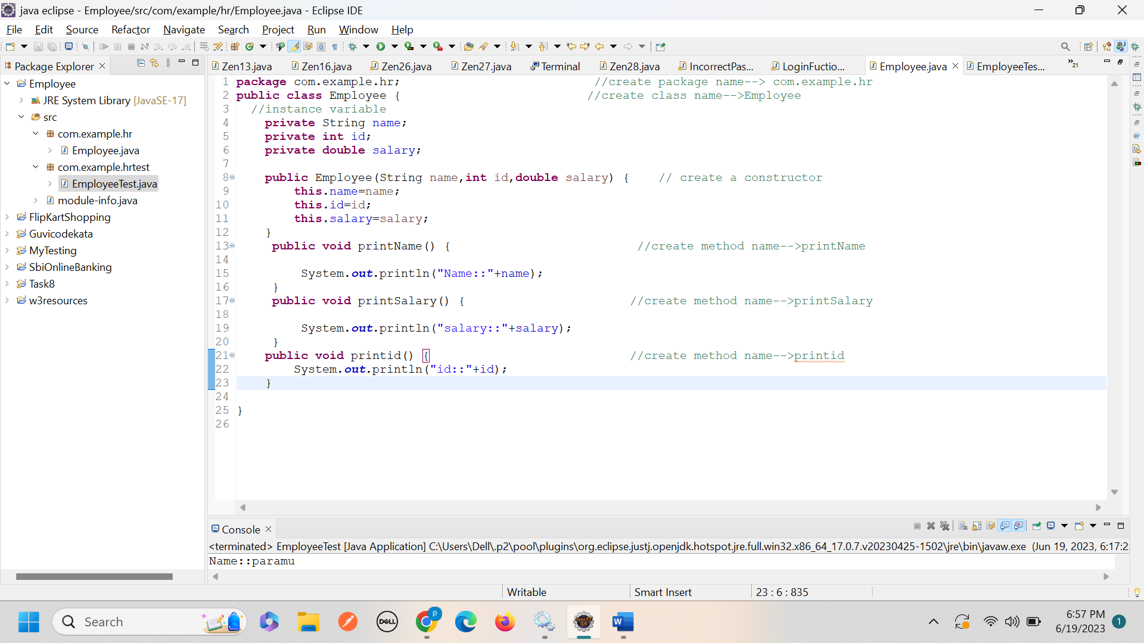

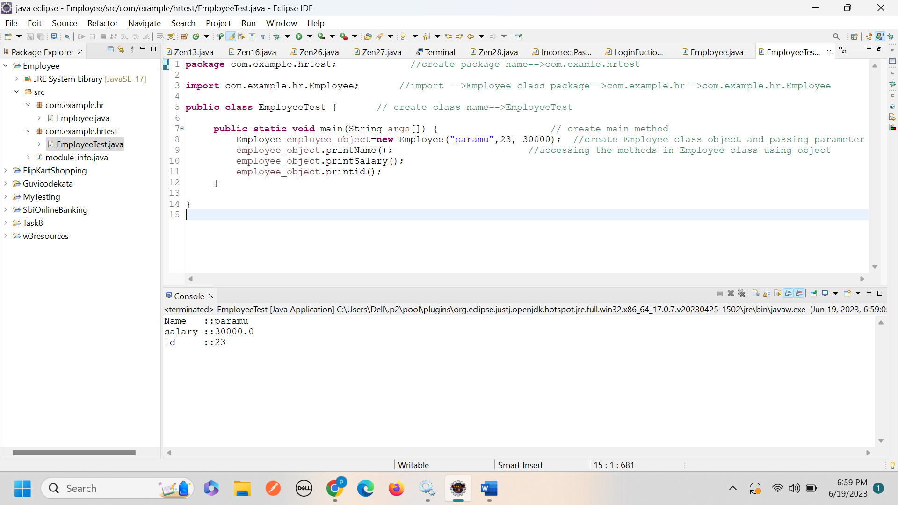

***2. Create an ArrayList of strings and then remove all the elements from the ArrayList.***

***Code and output Screenshot:***

**package com.Collection;**

**import java.util.ArrayList;**

**import java.util.List;**

**public class ArrayListProgram {**

**public static void main(String[] args) {**

**//create an ArrayList to store data**

**List<String> fruits=new ArrayList<>();**

**fruits.add("Apple");**

**fruits.add("orange");**

**fruits.add("Banana");**

**fruits.add("Grapes");**

**fruits.add("PineApple");**

**System.*out*.println(fruits);**

**}**

**}**

**package com.Collection;**

**import java.util.ArrayList;**

**import java.util.List;**

**public class ArrayListProgram {**

**public static void main(String[] args) {**

**//create an ArrayList to store data**

**List<String> fruits=new ArrayList<>();**

**fruits.add("Apple");**

**fruits.add("orange");**

**fruits.add("Banana");**

**fruits.add("Grapes");**

**fruits.add("PineApple");**

**System.*out*.println(fruits);**

**fruits.removeAll(fruits);**

**System.*out*.println(fruits);**

**}**

**}**

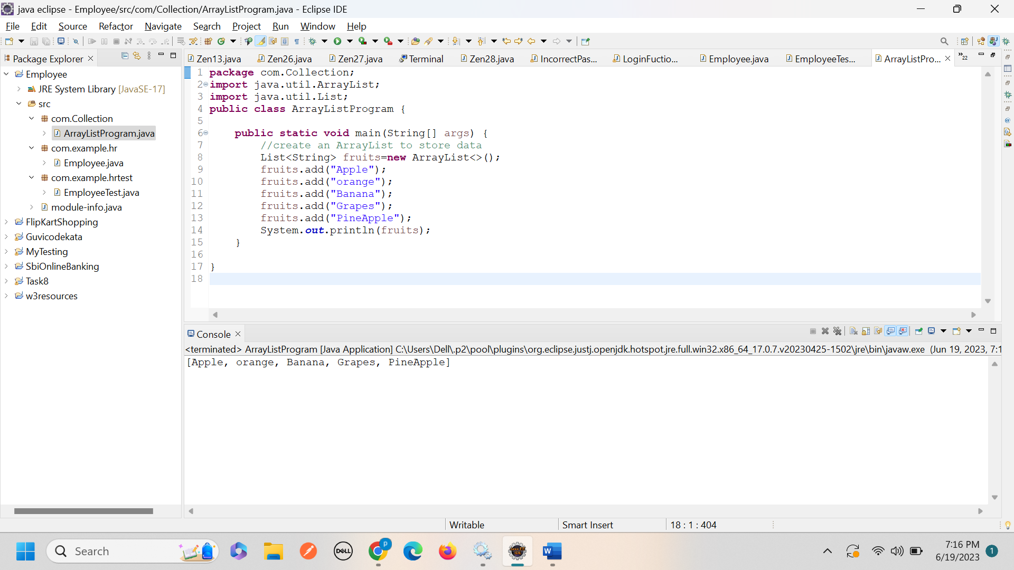

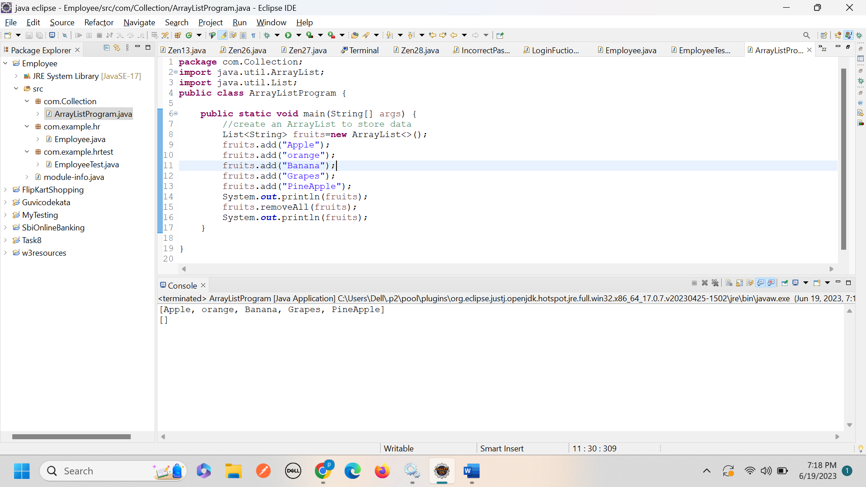

***3. Create TreeMap of Employee id and name, print the names in alphabetical order***

***Code:***

**package com.Collection.TreeMap;**

**import java.util.*;**

**import java.util.TreeMap;**

**public class TreeMapProgram {**

**public static void main(String[] args) {**

**//Declaring object of String and Integer pair**

**TreeMap<String,Integer> employeeMap=new TreeMap<>();**

**//using put method**

**//mapping integer value to string**

**employeeMap.put( "Banu",1);**

**employeeMap.put( "paramu",2);**

**employeeMap.put( "sankari",3);**

**employeeMap.put("Aashli",4);**

**employeeMap.put( "Devi",5);**

**System.out.println(employeeMap);**

**//System.out.println(employeeMap.values());**

**}**

**}**

**Output and Screenshot:**

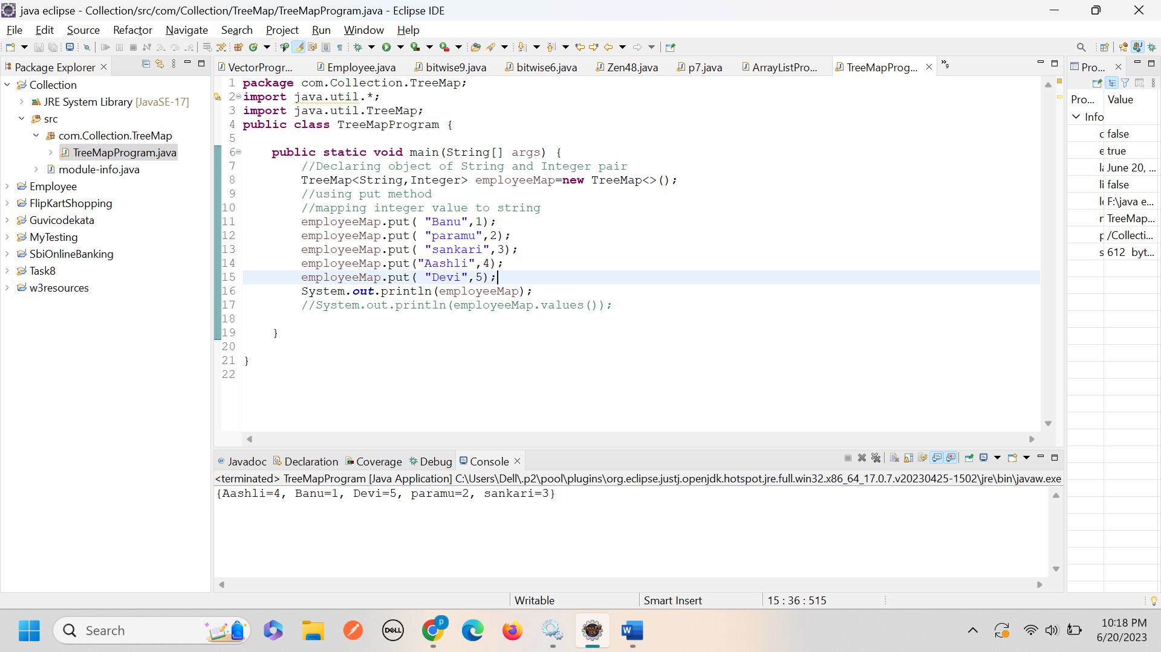

***4.Convert list to array***

***Code:***

package com.Collection.TreeMap;

import java.util.ArrayList;

import java.util.List;

import java.util.Arrays;

public class ListToArray {

public static void main(String[] args) {

List<Integer> list=new ArrayList<>();

list.add(10);

list.add(20);

list.add(30);

list.add(40);

list.add(50);

System.*out*.println(list);

//converting list to array

//using array toArray() method

Integer [] array=list.toArray(new Integer[0]);

//System.out.println(array);

for(Integer arr:array) { //printing element in array

System.*out*.print(arr+" ");

}

System.*out*.println();

System.*out*.println(Arrays.*toString*(array));

}

}

***Code and output screenshot:***

